Prophet uses an additive model:
y(t) =g(t) + s(t) + h(t) + εt ​
- g(t) → Trend (piecewise linear or logistic growth).
- s(t) → Seasonality (Fourier series-based; captures weekly/yearly cycles).
- h(t) → Holiday effects (user-defined list of events like Eid, Christmas, etc.).
- ε(t) → Noise (error term).

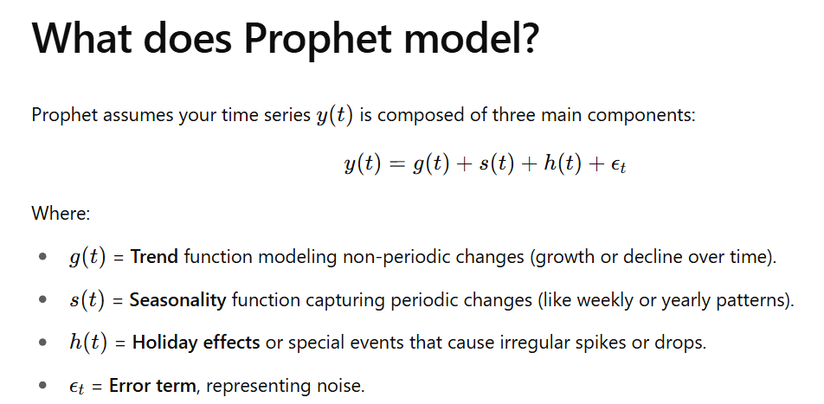

Key Features:
- Change points detection: Automatically finds places in the time series where the trend changes. It uses regularized logistic regressions.
- Flexible seasonality modeling: Built-in Fourier transforms handle complex seasonal cycles.
- Outlier resistance: Uses robust loss functions under the hood.
- Handles missing data, gaps, and large datasets better than ARIMA-like models.
Think of it as:
- SARIMA = rigid but statistically grounded.
- Prophet = flexible and scalable, built for business time series chaos.

